**Objective Questions Answers**

1. There were **9** missing values in the column Cuisines. After removing them, left with **9542** records.
2. Used the Vlookup function and filled in the countries in the original Dataset using Country Code.
3. Table representing the number of Restaurants in each Country.  
   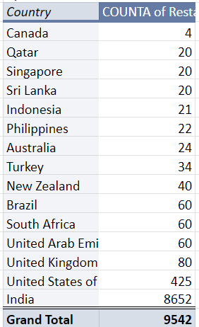
4. The number of restaurants opened has increased over the years.  
   Table representing number of Restaurants in each year  
   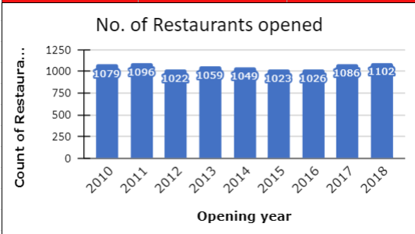
5. There are **388** Restaurants in India with a price range of **4.**
6. Table representing the average number of votes in each country.  
   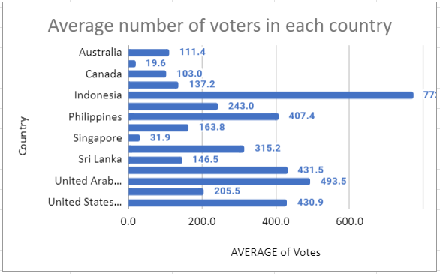

**Subjective Question Answers**

1. This table represents country-wise average ratings, the number of restaurants, the average number of votes, and the average cost for two in each country.

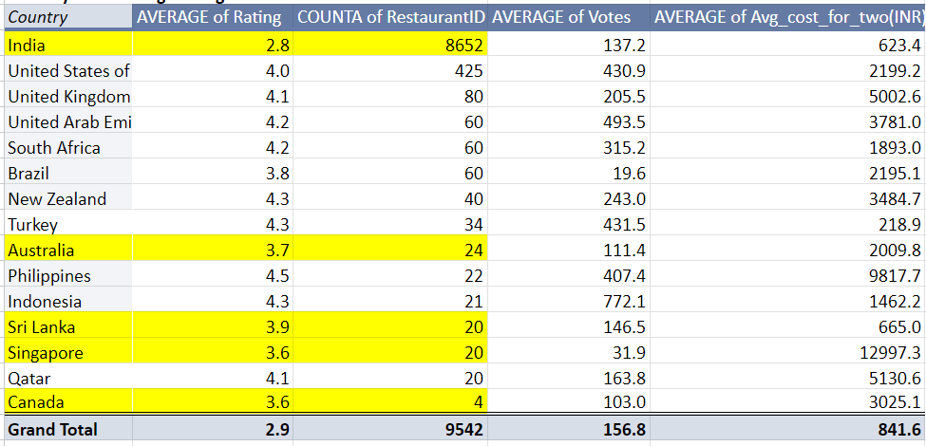

* 1. Based on the data in the table, there are the highest number of restaurants in **India** but the average rating of the restaurants is **2.8** which is comparatively less and with an average of **137** votes.
  2. Representing the count of restaurants in descending order, we see there are only **4** restaurants in **Canada** with an average rating of **3.6**.
  3. Similarly, In **Sri Lanka** and **Singapore**, there are only **20** restaurants with an average rating of **3.9** and **3.6** respectively.
  4. In **Australia**, there are **24** restaurants with an average **3.7** rating and the average cost for two is high.

Analyzing the above condition, there are 5 suggested countries where  
 we can set up new restaurants. Those are India, Canada, Australia, Sri Lanka and Singapore.

1. Suggested cities based on ratings in descending order are mentioned in the sheet. [Copy2 Zomato_Data.xlsx](https://docs.google.com/spreadsheets/d/14fqVRY31Vqfy5HDVGMrjhvAqiRsSexf0/edit#gid=574700032)
2. Calculated average ratings for each restaurant in the suggested countries.  
   Segregated restaurants into poor, intermediate, and good quality based on the following conditions.

| Ratings > 4.0 | Good quality |
| --- | --- |
| 3.5 <= Ratings <= 4.0 | Moderate quality |
| Ratings < 3.5 | Poor quality |

Mentioned in the following sheet. [Copy2 Zomato_Data.xlsx](https://docs.google.com/spreadsheets/d/14fqVRY31Vqfy5HDVGMrjhvAqiRsSexf0/edit#gid=820090315)

| *Quality* | COUNTA of RestaurantName |
| --- | --- |
| High quality | 505 |
| Moderate Quality | 1491 |
| Poor Quality | 4665 |
| **Grand Total** | **6661** |

1. Current expenditures on food in the suggested countries are mentioned below.  
   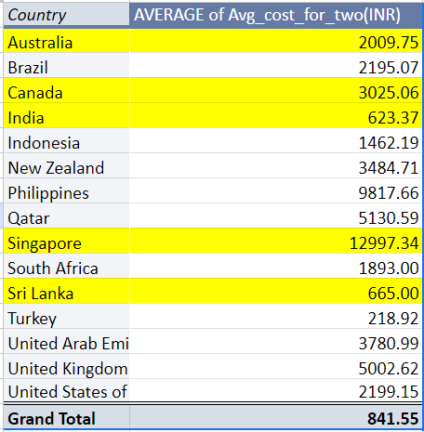
2. Names of the restaurants from the recommended countries that are competitors are those restaurants whose ratings >= 4.4.  
   Mentioned in the 3rd table in the following sheet.[Copy2 Zomato_Data.xlsx](https://docs.google.com/spreadsheets/d/14fqVRY31Vqfy5HDVGMrjhvAqiRsSexf0/edit#gid=918373456)

Names of the Restaurants in the rating group 1-2 or 2-3 are mentioned in the 1st table of the same sheet.

1. There are 603 selected cuisines with more than 4.0 ratings in the suggested countries. Removing all the duplicates of cuisines, we can focus on 126 unique cuisines in our new restaurants to get better feedback.
2. Analyzing the following table, 26% of restaurants offer online delivery with an average rating of 3.3, whereas 74% of restaurants that don’t offer online delivery have a 2.8 rating.  
   Comparing ratings, restaurants with online delivery have better ratings.  
   Similarly, 12% of restaurants offering table booking have better ratings than 88% of restaurants that don’t provide the same service.

| 4. Count of restaurants offering online delivery | | | | |
| --- | --- | --- | --- | --- |
| Count of restaurants | Online_delivery | % of restaurants | Average ratings | Comparison of ratings |
| 2451 | Yes | 25.69% | 3.3 | 0.5 |
| 7091 | No | 74.31% | 2.8 |  |
| 5. Count of restaurants offering table booking | | | | |
| Count of restaurants | Table booking | % of restaurants | Average ratings | Comparison of ratings |
| 1158 | Yes | 12.14% | 3.5 | 0.7 |
| 8384 | No | 87.86% | 2.8 |  |

1. There is a positive correlation between rates of cuisine and ratings.  
   
2. Distribution of number of restaurants of different price ranges in all other countries.  
   